
NAME: BISMA FATIMA
CLASS: CS A
ROLL NO: F24605036
COURSE: INFORMATION SECURITY
COURSE CODE: CS-291
LECTURER: MISS ATTIA ASHRAF

LAB 06

Introduction to OpenSSL– Certificates and Secure Communication
Lab Activities
1. CSR Generation: Generate a CSR with detailed organizational information and extract the details.
Generate a CSR
1. Use the following command to generate a new private key and a CSR:
openssl req -new -newkey rsa:2048 -nodes -keyout private_key.pem -out mycsr.csr
o This command generates a 2048-bit RSA private key and a CSR.
o You will be prompted to enter various details such as
▪ Country
▪ State
▪ City
▪ Organization name
▪ Common name
▪ Email
▪ Password
o These details will be embedded in the CSR.
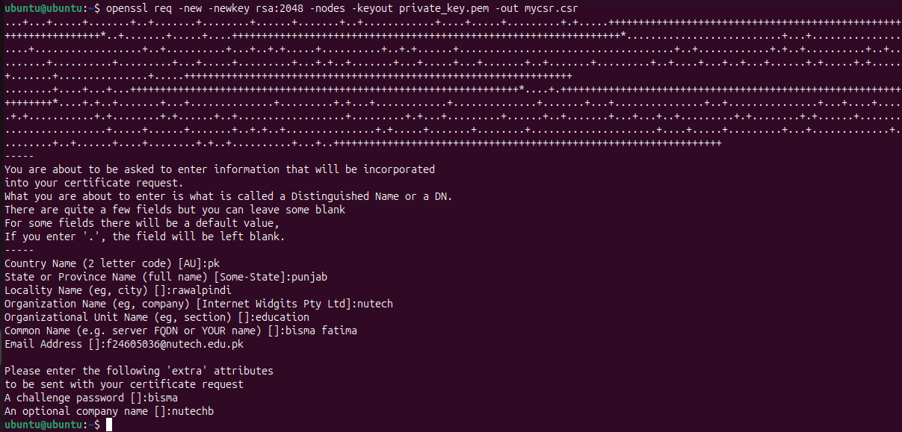
Verify the CSR
∙ This command will display the contents of the CSR in a human-readable format and verify its structure
openssl req -text -noout -verify -in mycsr.csr
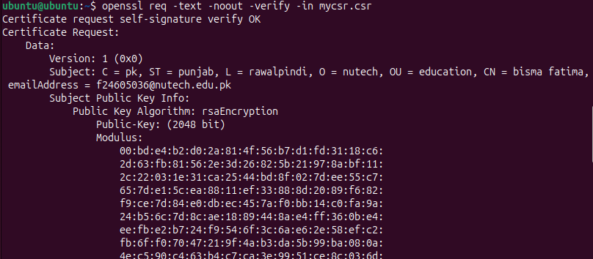

2. Self-Signed Certificate Creation: Create and verify a self-signed certificate using OpenSSL.
Creating a Self-Signed Certificate
After generating a CSR, we will create a self-signed certificate. This type of certificate is often used in testing environments or for internal use where the certificate doesn’t need to be verified by an external CA.
1. To create a self-signed certificate that is valid for 365 days, use the following command:
openssl x509 -req -days 365 -in mycsr.csr -signkey private_key.pem -out mycert.pem
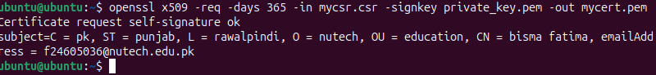
2. Verify the self-signed certificate using:
openssl x509 -text -noout -in mycert.pem
This command will display the details of the self-signed certificate.
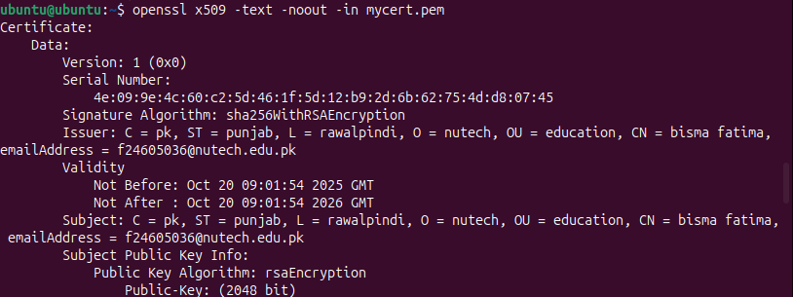

3. Certificate Verification: Run OpenSSL commands to verify the validity of the self-signed certificate.
Part 3: Verifying the Certificate
After creating the self-signed certificate, it is important to verify its authenticity and ensure it is properly signed. To verify the self-signed certificate, use the following command:
openssl verify -CAfile mycert.pem mycert.pem
If the verification is successful, you will see an output indicating that the certificate is valid. 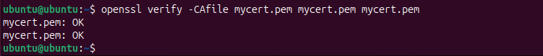

Part 4: Exploring the Role of Certificates in SSL/TLS
Certificates are integral to the SSL/TLS protocol, ensuring that the data exchanged between a client and a server is encrypted and authenticated. SSL/TLS certificates are usually issued by trusted third-party CAs and contain the public key of the server, which clients use to initiate secure communication.
Understanding SSL/TLS Handshake
1. The SSL/TLS Handshake process can be summarized as follows:
o The client requests a secure connection by sending a ClientHello message to the server.
o The server responds with a ServerHello message, including its certificate containing the server’s public key.
o The client verifies the certificate and, if valid, generates a symmetric key for encryption. It encrypts this key using the server’s public key and sends it to the server.
o The server decrypts the symmetric key using its private key.
o Both parties use the symmetric key to secure further communication.
This process highlights how certificates ensure the authenticity and security of the connection.
Understanding SSL/TLS Certificates
1. Certificates in SSL/TLS:
o Self-Signed Certificates: Often used for internal testing and development environments.
o CA-Signed Certificates: Issued by Certificate Authorities and trusted by browsers and clients for public-facing websites.
o Wildcard Certificates: Used to secure multiple subdomains with a single certificate.
o Extended Validation (EV) Certificates: Provide the highest level of trust and authentication.
2. Discuss the difference between self-signed and CA-signed certificates and the importance of the SSL/TLS protocol in web security.
Feature | Self-Signed Certificate | CA-Signed Certificate
Issuer | Signed by the entity itself | Signed by a trusted Certificate Authority (CA)
Trust Level | Not trusted by browsers or operating systems | Trusted by default in browsers and OSs
Use Case | Internal testing, development environments | Public-facing websites, production environments
Cost | Free | Often requires payment (some CAs offer free certs)
Validation | No external validation | Validated by CA (can be DV, OV, or EV)
Security Risk | Higher risk of impersonation or MITM attacks | Lower risk due to third-party verification
Browser Warnings | Triggers security warnings | No warnings if properly installed

Lab Summary
In this lab, you learned how to generate a CSR, create a self-signed certificate, and verify the certificate using OpenSSL. These operations are essential in establishing trust in secure communication protocols, especially SSL/TLS. Additionally, you explored how certificates are used to authenticate parties in secure communication, ensuring that data exchanged over the network is encrypted and protected.

LAB 07
Performance Comparison of DES and RSA
Part 1: Data Encryption Standards (DES) Algorithm
javac des_algo.java
java DES
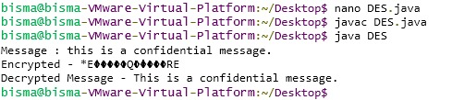

Part 2: Rivest–Shamir–Adleman (RSA) Algorithm
javac rsa_algo.java
java RSA
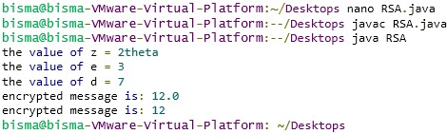
Graph summary:
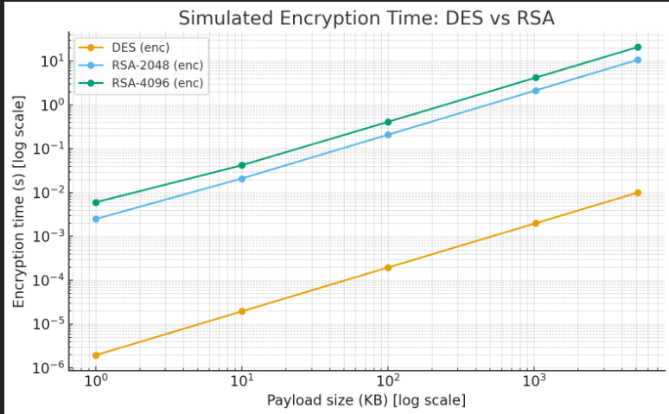
Decryption:
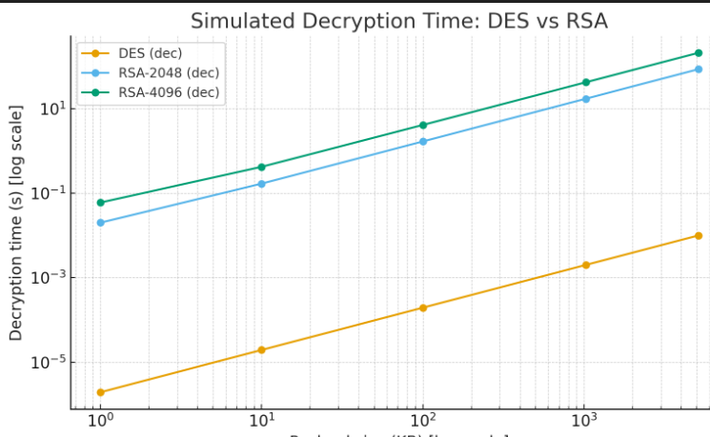
2. Performance Comparison
Method
- Run encryption and decryption for both algorithms
- Vary message sizes (e.g., 128 bytes, 1 KB, 5 KB)
- Vary RSA key sizes (e.g., 1024, 2048, 4096 bits)
- Measure execution time using System.nanoTime() or System.currentTimeMillis()
Sample Table
Message Size | DES Encrypt (ms) | DES Decrypt (ms) | RSA Encrypt (ms) | RSA Decrypt (ms)
128 bytes | 2 | 1 | 15 | 120
1 KB | 5 | 3 | 50 | 400
5 KB | 20 | 15 | 200 | 1600
Observations
- DES is faster due to its symmetric nature and smaller key size
- RSA is slower, especially during decryption, due to large key operations
- RSA performance degrades with larger key sizes and message lengths
3. Security Considerations
DES
- Strengths: Fast, simple, widely studied
- Weaknesses: Small key size (56 bits), vulnerable to brute-force attacks
- Status: Deprecated; replaced by AES
RSA
- Strengths: Secure with large keys, supports digital signatures and key exchange
- Weaknesses: Computationally expensive, vulnerable to quantum attacks
- Status: Still widely used, often combined with symmetric encryption in hybrid systems
Hybrid Use
RSA is typically used to encrypt a symmetric key, which is then used for bulk encryption with a faster algorithm like AES. This balances security and performance.
4. How DES Was Broken
- In 1998, the Electronic Frontier Foundation built a machine that brute-forced DES in 56 hours
- Today, with modern hardware, DES can be brute-forced in under 24 hours
- The 56-bit key space (2^56) is too small for modern security standards
5. Breaking RSA in Polynomial Time
- RSA relies on the difficulty of factoring large integers
- No known classical polynomial-time algorithm exists for factoring
- Quantum algorithms like Shor’s algorithm could break RSA in polynomial time
- Breaking RSA with 2048-bit keys would require millions of stable qubits, which is beyond current quantum capabilities

